RESUME  Btech - Student  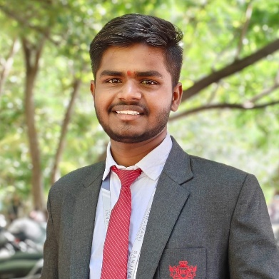 | Harshad Gholap  Dhangar Vasti,Yesgaon  Kopergaon-423601  Mob No. 9579977310  harshadgholap2025@gmail.com

I am a hard working person with polite behaviour. I give my best to any work which is given to me and encourages my colleagues too.
I love to test or perform electronics experiments and have interests in cars, mechanical engines and EV motors.

—
Skills
—
Education

Specializations in Java, Python, C++ and software designing.
Excellent communication skills, Know Languages are English, Hindi, Marathi and Japanese.
Strong Basics in Electrical circuits and Having Adequate Knowledge of Power Distribution and Specialization in VLSI.

Primary School - Sanjivani Medium School,kopergaon
Year 2011 to 2017
Std KG to 3rd

Secondary School - New English School,Yesgaon
Year 2017 to 2023
Std - 4th to 10th

High School - Sanjivani Junior College, Kopargaon
Year 2023 to 2025
Std - 11th to 12th

Engineering College - Sanjivani College Of Engineering, Kopargoan
Month - 2025 to 2029

From First Year To Final Year - Electrical Engineering

—
Work Experience
Chief Electrical Engineer in Adani Power
Led the design and development of a cutting - edge electrical system.
Managed a team of 20 engineers.
Oversaw the production of high-tech weaponry.
Developed the 300 acres solar panel project with 50 engineers and 200 co-workers and worked for Adani Power for 5 years.

Electrical Engineer in Mahindra
Designed and implemented electrical circuits for various projects.
Worked on the development of EV rotors.
To develop the PCBs for automobile infotainment systems and worked for Mahindra for 2.5 years.

— Summary | A well passionate engineer in Electrical Engineering who has qualified the SSC, HSC and state entrance examination. Completed my degree in EE and worked for Adani Power Limited for 5 years as an chief Electrical Engineering and handled the design and development of production with 20 co-engineers. Developed a massive 300 acres solar panel project for sustainable energy and also worked in making PCBs and EV rotors in Mahindra.
Parameter | Mahindra | Adani power
Working Duration | 2.5 years | 5 years
Post | Fresher | HR
Salary | 5 Lakhs | 13 Lakhs
—
Table

